**Panelizing Using Mentor Graphics Layout 9.4**

Layout is not a program that is designed to do panelizing. However it is possible to achieve by making use of the *Reuse* function in PADS. The version of software that this guide will be using is Mentor Graphics PADS Layout 9.4.

Open up your project in Layout

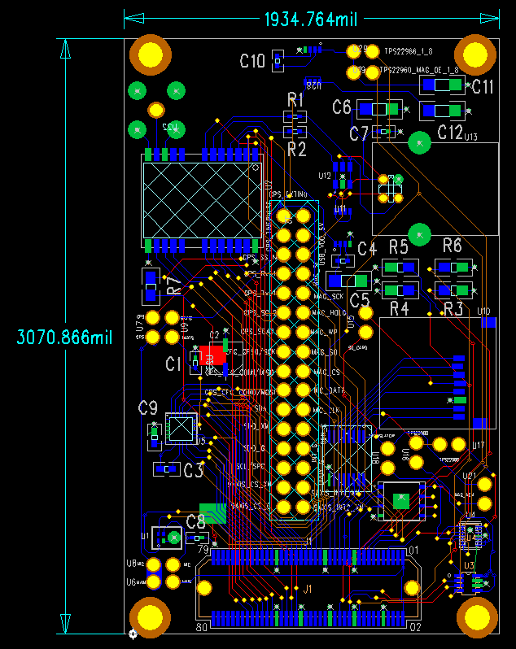

*Fig 1: This will be the board that will be used to demonstrate the use of the Reuse function in PADs to panelize.*

You will want to be in drafting mode for the first part of this tutorial.

Preparing your design for reuse  
1) First we are going to remove any unnecessary documentation from the design that we do not want reused. In this example we will remove the board dimensions. You will also need to remove the **Board Outline** (If you have one) as this will not be saved in the *Reuse* file. Even though it is not saved, you will want to remove it since PADS does not allow multiple board outlines in the same project, and we are going to be making a new one to accommodate the multiple boards.

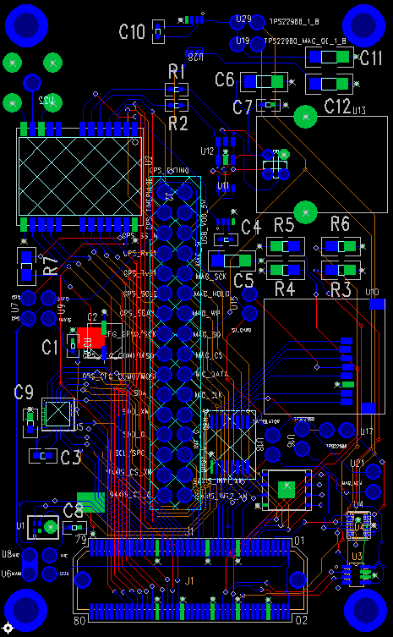

*Fig 2: Updated portion of the board. Note that the board-outline and dimensions are gone*

2) Display copper cut-outs and drawings. We will want the copper cut-outs selected for this *reuse*. In this project I just have one plane that is labeled *GND* that is purely copper. So that will need to be displayed. To do this press ‘ctrl+alt+c’ to bring up the *Display Colors* *Setup*, make sure “Copper” has check mark in it and hit “OK”

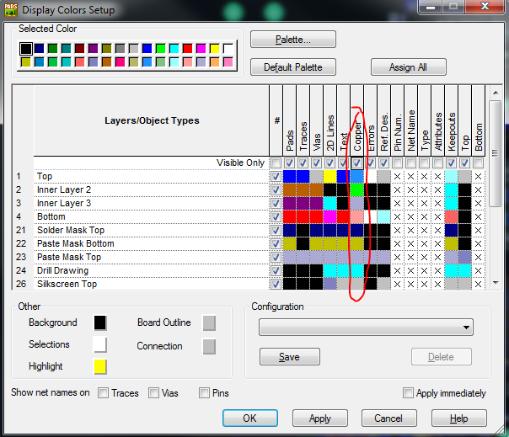

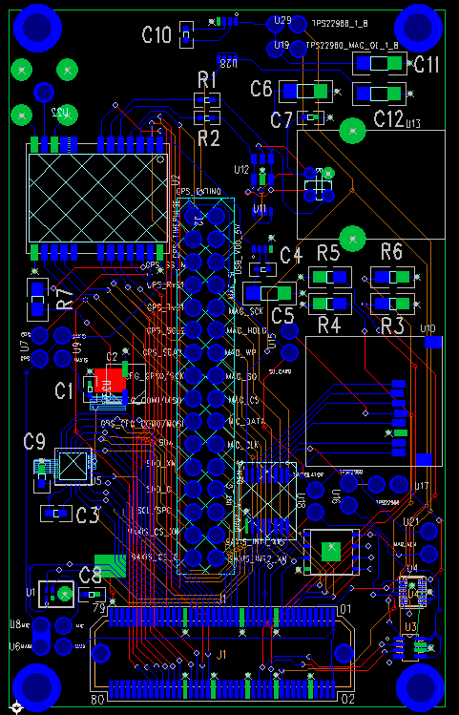

*Fig 4: Note the green outline around the board. This is my copper plane that is being used for GND*

This is a very important step. If you do not do this, it is likely that you will not select the appropriate plane and you will encounter problems when you are using your *Reuse* file.

3) Save your project. You will want to save your project at this point (make sure to name it something different) as creating a R*euse* will make us unable to edit or move the original design.

Create your reuse

1. Make sure you are viewing all layers. To do this there is a selection drop down menu in the upper left hand corner of the screen by the *Save* button. Make sure <All Layers> is selected and displayed.
2. In select mode make sure you have it set to *Select Anything*. To do this you can right-click in blank space (nothing with a component or trace or via) and click on “Select Anything”
3. Select your whole project, right-click, and click on “Make Reuse”

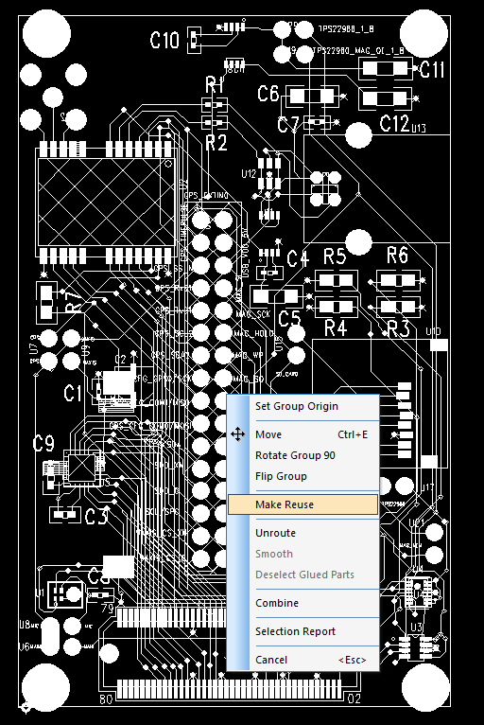

*Fig 5: Make sure you select everything.*

1. In the *Reuse Type* boxname your reuse and hit “OK”. Select your save location and hit “OK”

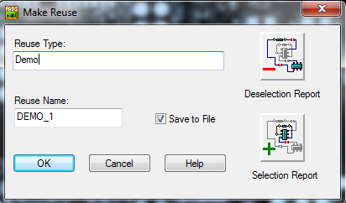

*Fig 6: name your reuse. For this example we will call ours “Demo”*

1. Re-open your project. Making something a R*euse* means that it cannot be edited or moved without breaking the R*euse* first. For simplicity sake we will just reload the project to the point that we saved it at. You DO NOT want to overwrite the current project. So when your reload it make sure you click “NO” on the prompt asking if you want to save.

Verify your reuse

Before we proceed we need to verify our R*euse* file first to check if we missed anything (specifically copper)

1. With your open design go into *ECO* mode by clicking the “eco toolbar” button at the top. If a prompt shows up saying *ECO Options* click “OK”
2. We now need to turn off *Design Rule Checking* to do this type “DRO” and hit the *Enter* key. This will turn of the *DRC*.
3. In the ECO toolbar press the button that says “Add Reuse”. Browse to the location that you saved your reuse file and open it. You will get a prompt showing the *Reuse Properties* in the name box it should show the name of your reuse with a number following. Click on the “Net Properties” button.

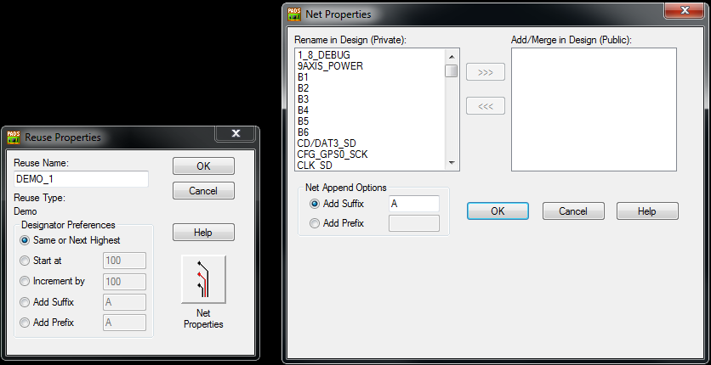

*Fig 7: There should be nothing in the ”Add/Merge in Design (Public)” box. If there is you likely made a mistake in your selection. If you know you didn’t make a mistake, just move the net over to the (private) box*

1. Make sure that there is nothing in the *(Public)* box and click “OK”.
2. Click *OK* to the ”Reuse Properties” box.
3. Click “yes” on the prompt that asks if you want to show report. This will show you if there were any errors.

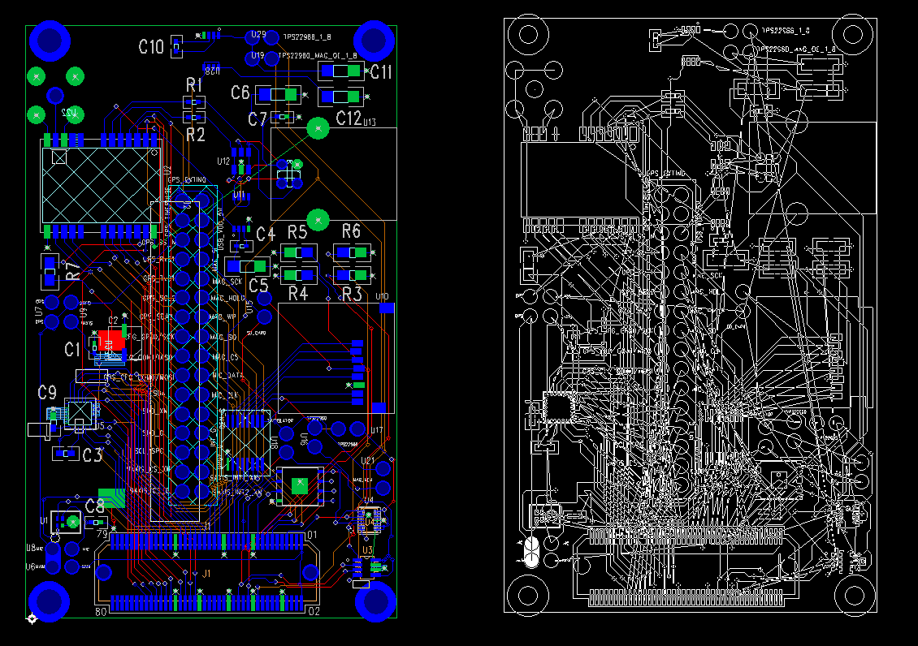

*Fig 8: This should look something close to what you screen looks like now*

1. At this point you should just place the part anywhere that is not on top of the other part. Note, once you place the part it cannot be moved again. You will have to delete it and add another R*euse*. However it doesn’t matter where you put it right now, as we are just verifying it.
2. Connect all your planes by going “tools>Pour Manager>Plane Connect” and click “start”
3. Verify your design by clicking “tools>Verify Design”. Verify the clearance, connectivity, and Plane.
4. If you did this right you should have no new errors. If you do then first try and make sure all your nets copied over.

Set up your project for placing your multiple reuses

1. Reload your previous project (the one that was mentioned you should save)
2. Create your board size that will fit the number of designs that you want
   1. For this guide I will move the design off of the origin using the selection process described above (make sure you get everything) and then create the board outline.
   2. Create a 2D line near the bottom of the board outline with a width of .01 (“right-click>width”). This will be used as a reference point to align the boards correctly on the Y axis. You may do the same with the X axis, if you wish.
   3. Make sure you have your grid size appropriately set. For this example we will use 1. To do this type “G1” and “GD1” this will set your grid size to 1.

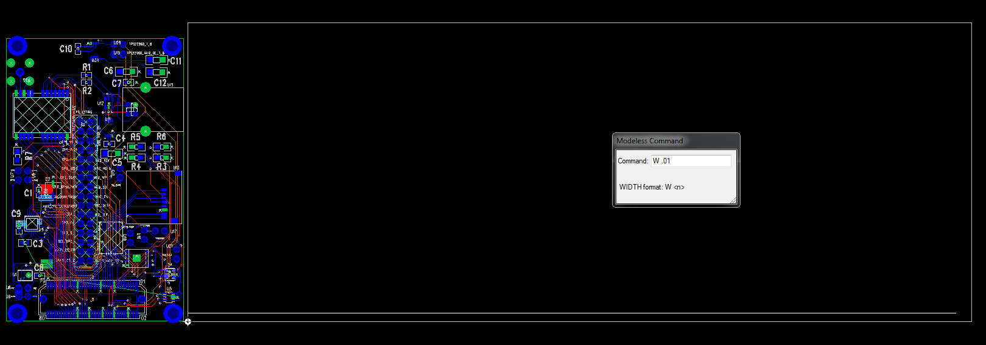

*Fig 9: Your project should look something like this. A board outline with a line of width .01 on the bottom for a reference point.*

1. To align with your reference line, make sure that you zoom in as far as you can. The line will turn blue when you are touching it.

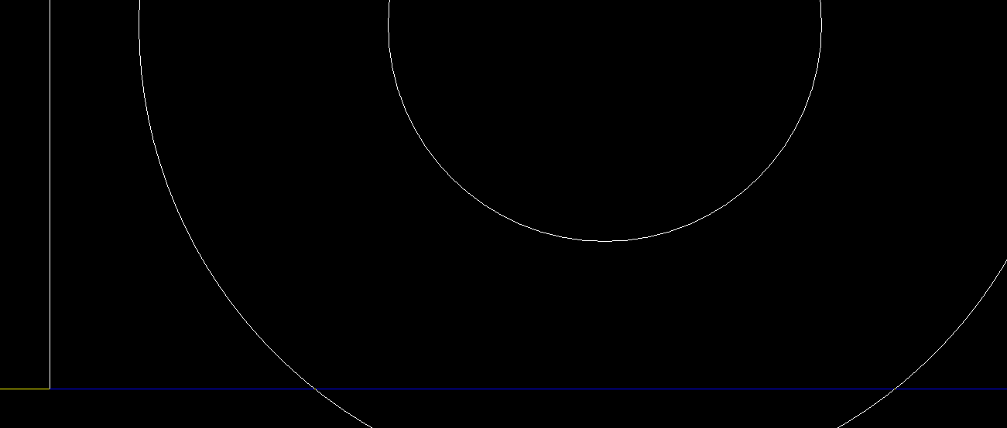

*Fig 10: Not that the line is blue when the copper line touches the reference line and yellow where it does not. Make sure you are zoomed in as far as you can to insure you get the greatest accuracy.*

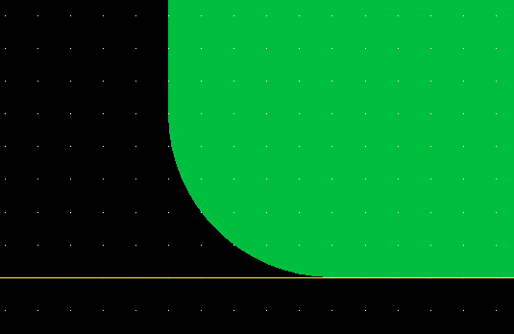

*Fig 11: Here we are verifying that the design is flush with the reference line. Each dot on the grid displayed above is 1 mil so the design is as flush as we are going to get with this grid size. It is important to do this so you have a constant distance that you can reference for the other parts.*

1. At this point you are going to want to save again. As working with reuses can be a bit tedious and messing up can cause problems.

Place your other reuse designs

1. Follow steps 1-10 again in the “*verify your reuse”* section of this guide. This time aligning your R*euse* with the reference line (make sure you zoom in as close as you can).
   1. **IMPORTANT NOTE:** Once you place your R*euse* you cannot move or modify it again. If you need to move it you will need to delete it and try again. If you really screw up just reload the design that was previously saved.
   2. If you get the prompt telling you that a R*euse* already exists, press “OK”. It is just asking if you want to make another copy.

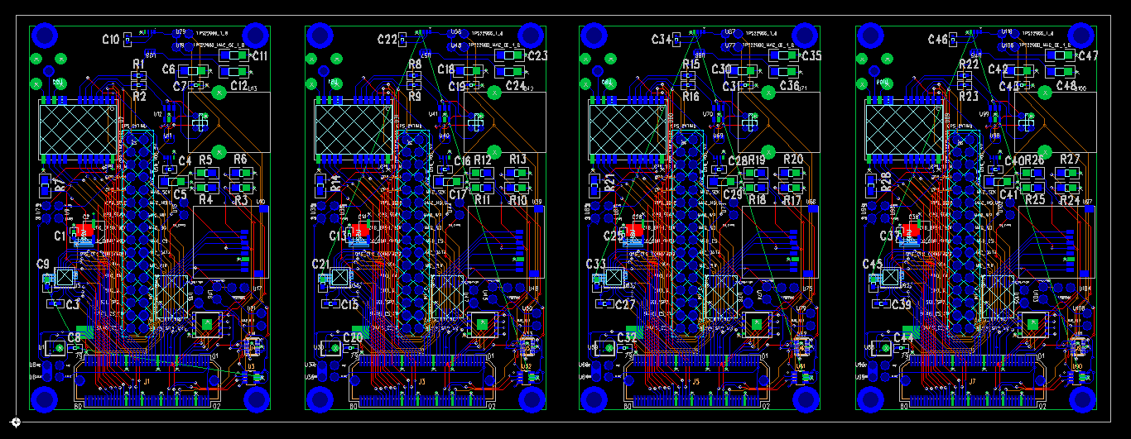

*Fig 12: Final version of the panelized design using Layout. Note the board outline and Y axis alignment.*

1. After you are finished placing all your designs, remove the 2D reference line that you created. If you do not, you will get errors when you preform your DFM check. Make sure you perform a plane connect, and verify that there are no connection errors or clearance errors. If you have none, then you are done and may create your gerber files and send your design off to get checked by a DFM.
   1. If you do have errors make sure that all your nets are *Private* in your reuses. If they are not this is a common cause of issuses